
Year 10
Pathway 2

Test 1
Total Marks: 24 marks
Name: _________________________________________ Total Time: 25 minutes

Show working and answers on this sheet. Show working in sufficient detail to support your answers. Incorrect answers without supporting reasoning may be allocated zero marks.
Calculator and note sheet (1 A4 Page) allowed
1. [5]
The planet Pluto is 5.9 × 10⁹ km from the Sun. The distance from Earth to the Moon is
3.84 × 10⁵ km.
(a) Write both distances as expanded numbers.

(b) How many Earth–Moon distances can fit between the Sun and Pluto. Write the answer in standard form, correct to two decimal places.

(c) Assume that the Moon’s orbit is a circle. What is the circumference of that circle? Give your answer in scientific notation, correct to three decimal places.
Formula$C=2πr$

2. How much will $8000 be worth if it has been invested for 3 years with an interest rate of 2% p.a. compounding yearly? Give your answer correct to the nearest dollar. [2]

3. A $10 000 investment is placed in a bank returning 6% compound interest. Find the value of the investment, correct to the nearest cent, after a year if interest is calculated every:
(a) six months [2]

(b) month. [2]

4. Plot the following points onto the graph, eye in the line of best fit and describe the relationship between x and y. [5]
(1, 3), (1, 2), (3, 2.5), (4, 1), (5, 2), (6, 0.5), (7, 0), (8, 1)

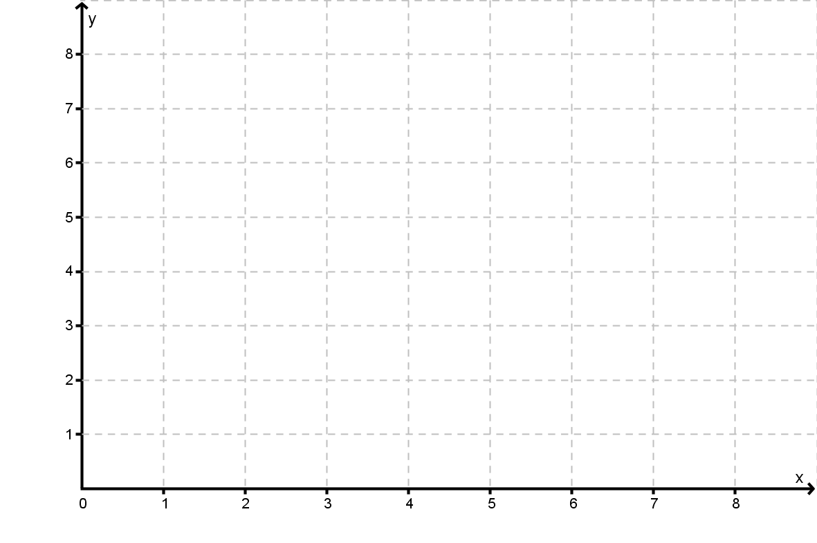

5. a) Find the mean, median and IQR of the scores for Maths and English tests. [6]

English | 40 | 42 | 28 | 30 | 50 | 39 | 41 | 32
Maths | 42 | 48 | 24 | 32 | 45 | 14 | 39 | 40

(b) Comment on the statistical values calculated and compare English and Maths results. [2]

